**CO226-Database Systems**

**Lab Sheet Number: 03**

**Topic: Introduction to MySQL**

**Lab Date: 15/12/2021**

Wijerathne E.S.G.

E/18/397

**Lab task:**

Create a suitable database to store data coming from the HTML page you have created in Lab 1. First, log into MySQL server and create a database named E18XXXLab03.Then create a suitable table in the database to store customer order details. When creating the table, choose suitable attribute names and data types for each field. Selecta suitable attribute as the primary key for the table. Refer MySQL documentation for the details. Submit SQL DDL statements used to create the table above as a text file. Populate the table with some data. Then write a few SQL statements to update and delete data in the table.

* Creating the database

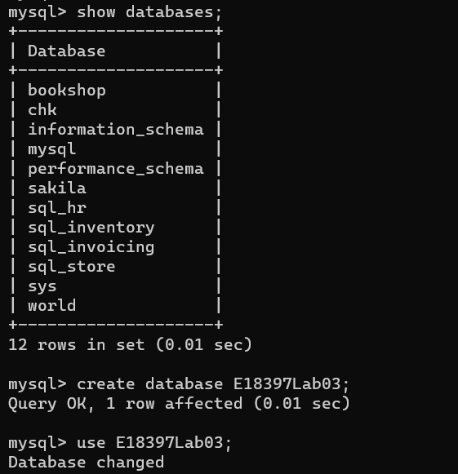

* Creating the table

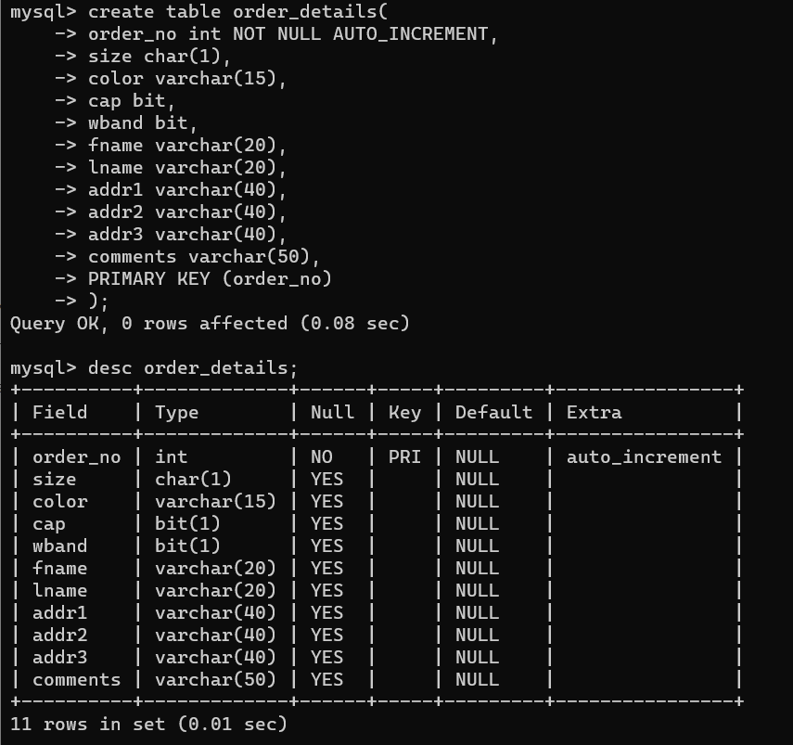

* Populating the table with values

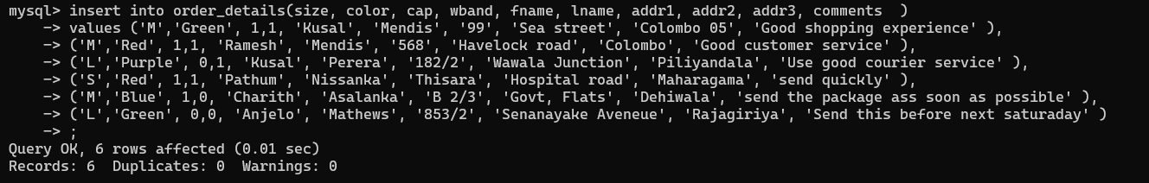

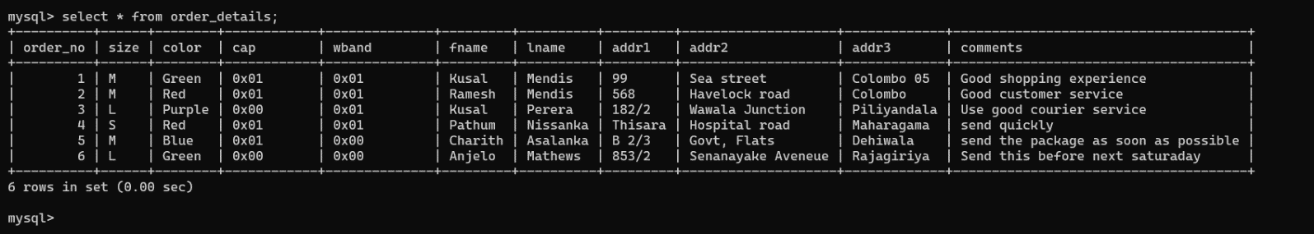

* Updating entries in the table

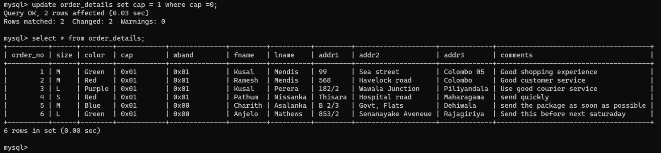

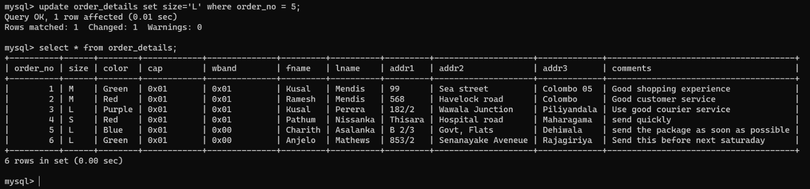

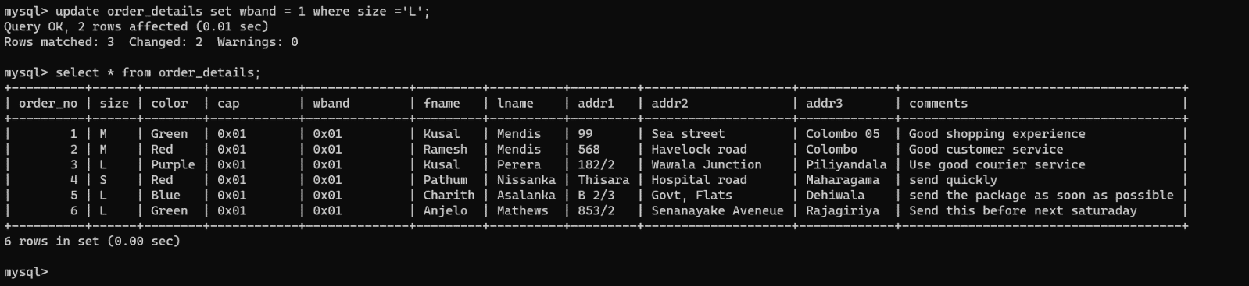

* Deleting entries in the table

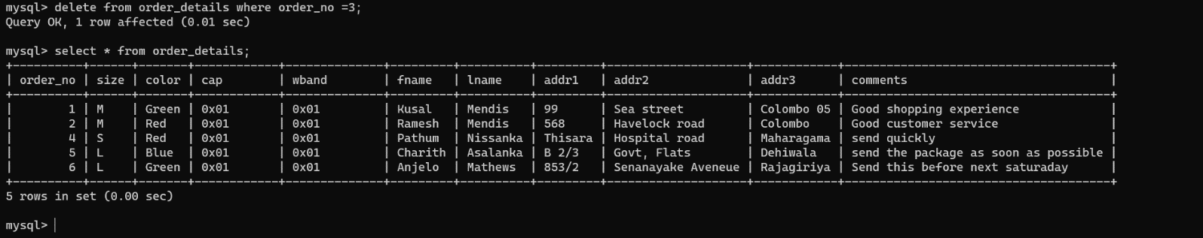

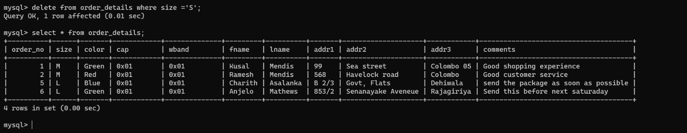

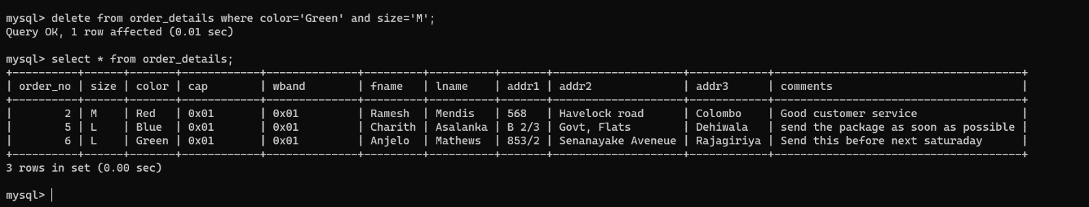

* Again, inserting an entry to table

